Ethics in Software Engineering — Summative Assessment
Erneste Ntezirizaza

Declaration
I am submitting under Pathway A. My project is based on: ARIA: An Adaptive Reforestation Intelligence Agent Using Reinforcement Learning for Drone-Based Aerial Seed Placement in Rwanda
I have considered the ethical implications of my research and obtained ethical clearance from the appropriate authority (REC Approval Code: M26-BSE-043, dated 18 June 2026) before any data collection, user testing, or deployment begins.

Part 1: Research Ethics Approval
[TEMPLATE] ALU_REC_Approved_Ethic_Clearance_Letter_-_M26.pdf
Link to video: [to be added]

Part Two: Ethical Risks and Mitigation
Given the nature of my project, the most serious ethical risks involve ecological risk from unverified deployment, data provenance and sovereignty, deployment bias across unevenly-resourced terrain zones, and protected-area regulatory compliance.
1. Ecological Risk from Unverified Deployment (Highest Priority)
ARIA's core function is to recommend where a drone should place seeds. If those recommendations were acted on directly without verification, an error in the model, such as a misjudged soil type, slope, or rainfall threshold, could result in real seeds being wasted on unsuitable terrain, or, worse, ecological disruption in sensitive areas. This risk matters most because it is the one place where a purely digital mistake could have a physical, ecological consequence rather than staying contained inside the software.
Mitigation actions taken: I restricted ARIA to five ICRAF-validated native species and designed and documented the system throughout as a decision-support simulation tool, not an autonomous deployment system. Every output requires field verification by the Rwanda Forestry Authority before any real-world planting takes place, and all results in the final capstone report are explicitly framed as simulation findings requiring field validation, not as ready-to-deploy recommendations.
2. Data Provenance and Sovereignty (High Priority)
ARIA integrates six distinct geospatial datasets (digital elevation, soil classification, rainfall, land use/land cover, protected areas, and species suitability). Using geospatial and environmental data without clear licensing or provenance can raise questions about data ownership and misuse, particularly where land-use data intersects with community or customary land rights.
Mitigation actions taken: every dataset I used is openly licensed, either CC BY 4.0, Public Domain, or Free/non-commercial, with source, format, resolution, and licence fully documented in the project's dataset table. No private, personal, or community-rights data is used anywhere in the system, a constraint I verified and documented before incorporating any data into training.
3. Deployment Bias Across Terrain Zones (Medium-High Priority)
Because the model's confidence depends on the density and quality of the underlying data, zones with historically weaker data coverage risk being systematically under-served by the tool's most confident recommendations, compounding rather than correcting existing regional inequality. This is not hypothetical for ARIA: the Eastern Savanna South zone has comparatively less data coverage and a higher recorded rate of forest loss than the other five evaluation zones.
Mitigation actions taken: rather than excluding it, I deliberately retained Eastern Savanna South as a held-out evaluation zone despite the data gap, and I designed the system's output maps to flag areas of low prediction confidence rather than presenting every recommendation with equal certainty, so that a human reviewer knows where extra scrutiny is warranted.
4. Protected-Area and Regulatory Compliance (Medium Priority)
Seed-placement recommendations that ignored legally protected areas would directly conflict with Rwandan conservation law and international protected-area frameworks, and could expose any future field deployment to legal and reputational risk.
Mitigation actions taken: I rasterised WDPA (World Database on Protected Areas) boundaries directly into the training environment as a hard constraint on the agent's action space. In the held-out evaluation across all six agro-ecological zones, the trained policy recorded zero protected-area violations.

Stakeholder and Societal Impact
ARIA affects multiple stakeholder groups with varying levels of vulnerability and influence over the system.
Primary stakeholders: the Rwanda Forestry Authority (RFA) sits at the centre of ARIA's stakeholder map, as it is the intended validator and adopter of any real-world recommendation and carries ultimate responsibility for planting decisions. Local communities and farmers across Rwanda's six agro-ecological zones are indirect but significant stakeholders, since reforestation outcomes are tied to fuelwood availability, soil fertility for adjacent farmland, and in some districts direct income from fruit or timber species. African Leadership University holds a reputational stake in the rigor and honesty of the research. Researchers in neighbouring countries (Kenya, Uganda, Tanzania, DRC) are potential future stakeholders, since the project's reliance on open-licensed data makes the underlying methodology replicable outside Rwanda.
Inclusion concerns: the system's reliability is uneven across zones by construction. Regions with weaker historical data coverage, such as Eastern Savanna South, will continue to receive less confident output unless the low-confidence flagging is respected by downstream human reviewers. Separately, ARIA's outputs (RL/PPO terminology, telemetry dashboards, Unity simulation) assume a technically literate operator; smallholder farmers and community members are unlikely to interpret the raw output directly and depend on the Rwanda Forestry Authority or similarly trained intermediaries to translate results into action.
Societal impact: ARIA demonstrates that terrain-adaptive reforestation decision-support can be built almost entirely from open-licensed data at near-zero direct cost (a total research budget of $35), which is significant for resource-constrained institutions across the region. Since Rwanda's national reforestation target is 65 million seedlings per year, even a modest improvement in placement survival could translate into millions of additional surviving trees per season. At the same time, because ARIA remains a simulation-only proof of concept at this stage, its ultimate societal benefit depends entirely on responsible field validation and adoption by the Rwanda Forestry Authority, not on the software in isolation.

Part Three: Frameworks, Journal.

Task 1: Ethical Frameworks and Regulations
Local and Regional Frameworks
1. Rwanda's Forest Landscape Restoration (FLR) Strategy 2024–2029
Rwanda's FLR Strategy, coordinated through AFR100, calls explicitly for data-driven, species-site-specific restoration decisions rather than uniform planting quotas (AFR100, 2025). This requirement directly shaped ARIA's core design choice: rather than a fixed flight-path or blanket-species approach, I built the system to match each of Rwanda's 115 ICRAF-validated tree species to zone-specific soil, rainfall, altitude, and slope conditions, and to restrict recommendations to only the five species validated for each terrain context. The Strategy's emphasis on data-driven restoration is also the direct justification for treating ARIA's own outputs as decision-support rather than autonomous action, since a data-driven policy still requires a human decision-maker in the loop.
2. Rwanda's National Strategy for Transformation 2 (NST2), 2024–2029
NST2 sets forest cover and landscape restoration as an explicit national priority alongside digital transformation, and links climate resilience directly to water security and rural income (Government of Rwanda, 2024). This framework shaped my decision to position ARIA as an open-source, low-cost reference architecture rather than a proprietary product. I built the entire system for $35 using open-access datasets and open-source libraries, specifically so that it could function as an evaluable proof of concept for the Rwanda Forestry Authority rather than a closed commercial tool, in keeping with NST2's dual priorities of environmental and digital transformation.
3. ALU Senate Research Ethics Committee (REC) Institutional Policy
The REC's ethical clearance conditions (Approval Code M26-BSE-043, dated 18 June 2026) require, among other things, that any change in methodology be reported within 48 hours and that any interaction with human participants follow strict consent, confidentiality, and non-coercion guidelines. This institutional framework shaped my decision to document, in the final capstone report, that no private, personal, or community-rights data is used anywhere in ARIA's pipeline, and to treat the REC's field-verification and consent principles as the template for how any future RFA or community consultation on real-world deployment should be conducted.
International Frameworks
4. Protected Planet — World Database on Protected Areas (WDPA)
The WDPA, jointly maintained by UNEP-WCMC and IUCN, is the internationally recognised authoritative source of protected-area boundaries (UNEP-WCMC & IUCN, 2026). Its data and underlying conservation principle, that legally protected land must not be treated as available for intervention, shaped a specific, hard-coded design decision in ARIA: I rasterised WDPA boundaries directly into the training environment as a constraint on the agent's action space, rather than leaving them as a post-hoc filter. This is why the held-out zone evaluation recorded zero protected-area violations across all six agro-ecological zones.
5. ACM Code of Ethics and Professional Conduct
The Association for Computing Machinery's Code of Ethics extends professional responsibility beyond legal compliance (Association for Computing Machinery, 2018). Principle 1.1 ("Contribute to society and to human well-being") and Principle 2.9 ("Design and implement systems that are robustly and usably secure") together shaped my decision to frame ARIA strictly as a decision-support simulation requiring field verification, rather than presenting an RL policy trained on procedurally generated and open geospatial data as ready for autonomous field use. Principle 2.5 ("Give comprehensive and thorough evaluations of computer systems and their impacts") is reflected in my final report's explicit documentation of the project's own limitations, including the incomplete ablation study, the absence of a baseline comparison, and the unused zone-selector component, rather than presenting only favourable results.
Framework Comparison and Synthesis
These five frameworks operate at different levels and with different force. Rwanda's FLR Strategy and NST2 are national policy instruments that set direction without imposing direct legal penalties on a student research project, but they meaningfully shaped ARIA's technical design, including species-site matching and its open-source architecture. The ALU REC policy is institutionally binding and was the framework with the most direct procedural consequence, since clearance had to be obtained before any field-facing work could proceed. The WDPA is an internationally maintained dataset and norm rather than binding law in itself, but its protected-area boundaries were converted into a hard technical constraint inside the system. The ACM Code is a professional, non-binding standard that nonetheless shaped the project's most important framing decision: presenting ARIA's outputs as decision-support requiring human and institutional verification, never as an autonomous authority.

Aspect | FLR Strategy | NST2 | ALU REC Policy | WDPA | ACM Code
Focus | Restoration policy | National development | Institutional ethics | Conservation data | Professional ethics
Binding | Policy guidance | Policy guidance | Institutionally binding | International norm/dataset | Professional standard
Enforcement | AFR100/RFA review | Government review | REC / university authority | UNEP-WCMC & IUCN | Professional reputation
Key ARIA Link | Species-site matching | Open-source, low-cost design | Pre-clearance, no personal data | Hard protected-area constraint | Decision-support framing, honest limitations

Together, these frameworks created a layered structure: institutional clearance before the work began, national policy shaping what the system optimises for, international conservation data enforced as a hard constraint, and a professional code shaping how results are reported and how much autonomy the system is allowed to claim.

Task 2: Project Journal
The entries below are drawn directly from my Google Calendar appointment records with my supervisor, Dirac Murairi, and are presented in chronological order. A screenshot of the calendar confirmation is included beneath each entry as evidence, except where noted.
Supervision Meeting Log 1
Date/Time | Thursday, 7 May 2026 • 9:30–10:00am (Google Meet)
Meeting Type | Capstone Office Hour
Person/Role | Erneste Ntezirizaza (Student) & Dirac Murairi (Supervisor)
Discussion Points | 1. Introduction to Capstone expectations and timeline. 2. Initial exploration of candidate project ideas, including the Rwanda reforestation concept. 3. Overview of the ethics and REC clearance process for field-relevant projects. 4. Discussion of data availability for a geospatial/RL approach.
Action Items | I will compare the two candidate project ideas against feasibility and data availability. I will begin scoping datasets for the reforestation concept by the next session.
Ethical Issues Raised | We flagged early that any geospatial or environmental dataset used would need its licensing and provenance checked before adoption.
Decisions Made | We agreed to develop both candidate ideas further before committing to one for the Capstone.
Calendar confirmation: Capstone Office Hour, Thursday 7 May 2026, 9:30–10:00am
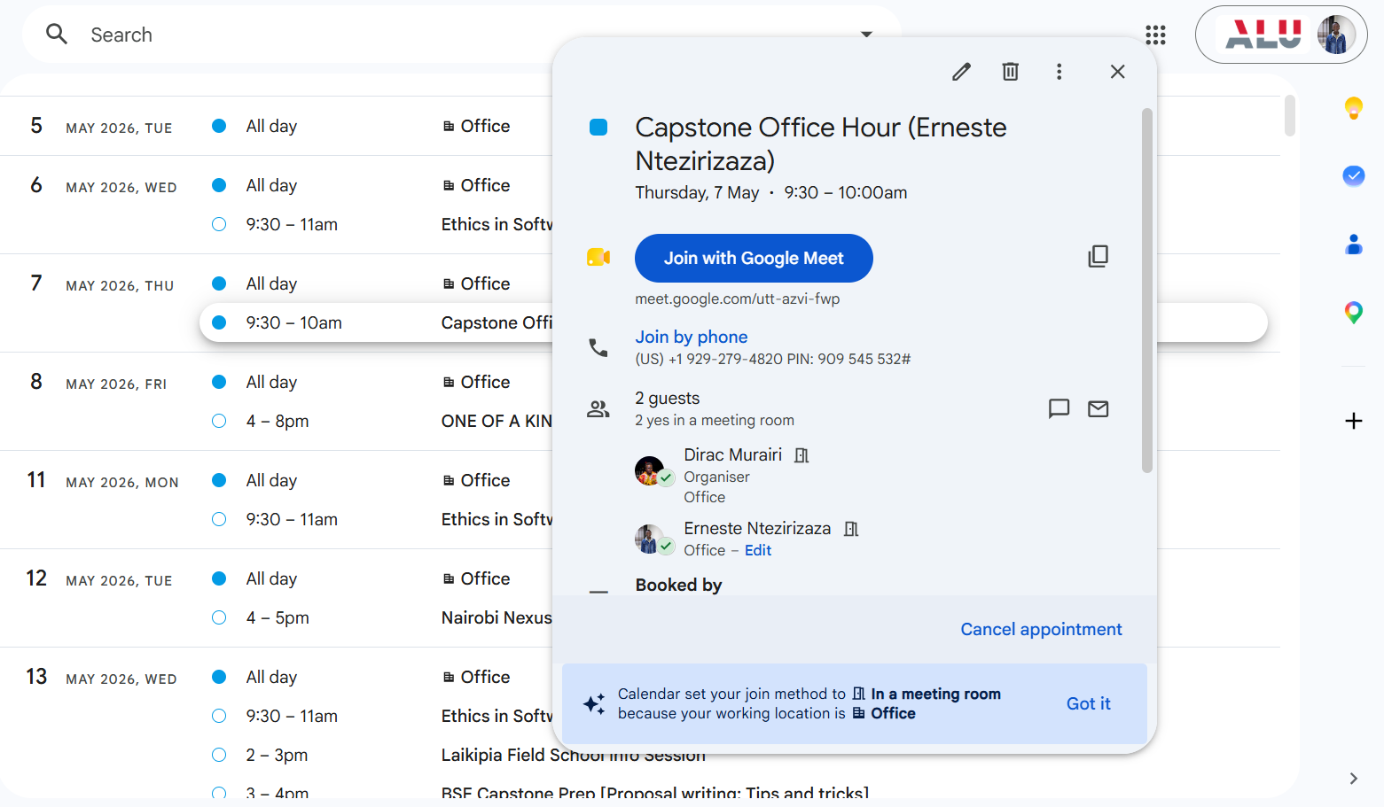
Supervision Meeting Log 2
Date/Time | Thursday, 21 May 2026 • 6:30–6:45pm (Google Meet)
Meeting Type | Mission Capstone 26-May-Term
Person/Role | Erneste Ntezirizaza (Student) & Dirac Murairi (Supervisor)
Discussion Points | 1. Refined the Rwanda reforestation problem statement. 2. Assessed feasibility of a reinforcement-learning approach within the eight-week Capstone timeline. 3. Checked alignment with ALU's Mission Capstone requirements. 4. Identified the core geospatial datasets that would be required: elevation, soil, rainfall, land cover, protected areas, species.
Action Items | I will draft the formal problem statement and research questions. I will confirm the six required datasets are openly accessible.
Ethical Issues Raised | We confirmed the project would not require collection of personal or human-subject data, simplifying the REC application.
Decisions Made | We confirmed the reforestation RL project (ARIA) as the final Capstone direction.
Calendar confirmation: Mission Capstone 26-May-Term, Thursday 21 May 2026, 6:30–6:45pm
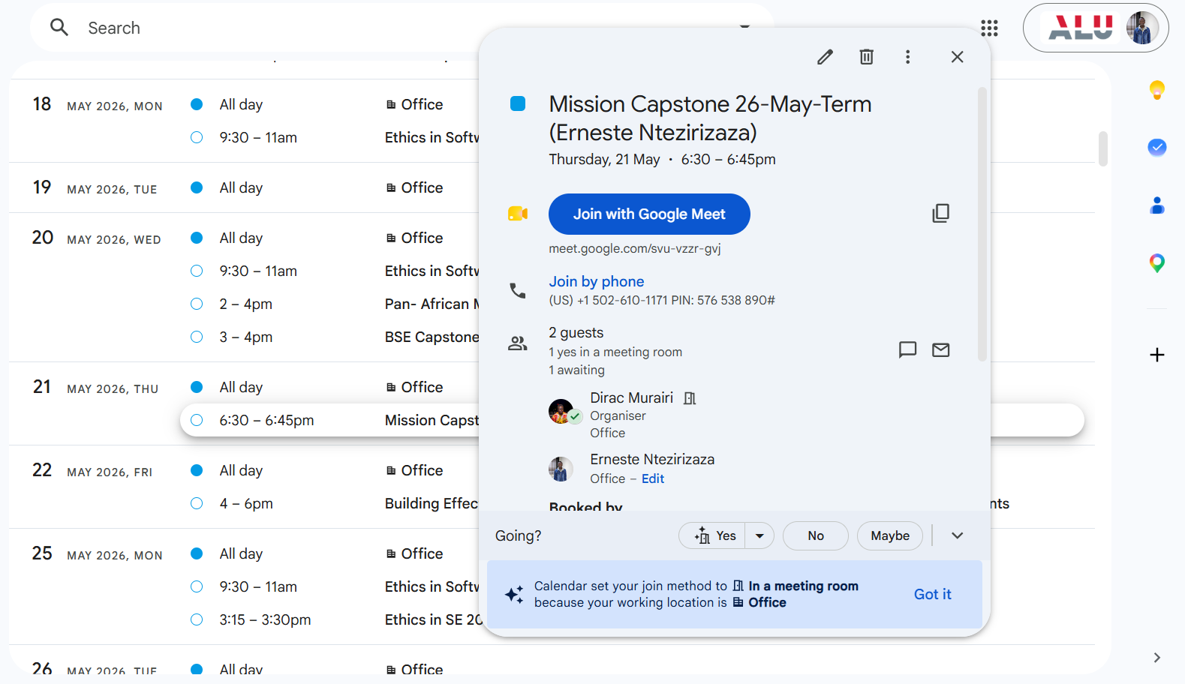
Supervision Meeting Log 3
Date/Time | Monday, 25 May 2026 • 3:15–3:30pm (Google Meet)
Meeting Type | Ethics in SE 2026 May Term
Person/Role | Erneste Ntezirizaza (Student) & Dirac Murairi (Supervisor)
Discussion Points | 1. Presented the ARIA concept for ethics-readiness review. 2. Discussed the REC ethical clearance process required before any field-relevant work. 3. Reviewed the licensing status of the six candidate datasets (CC BY 4.0, Public Domain, WDPA free non-commercial). 4. Discussed how to frame the system's outputs given the ecological risk of a drone-seeding recommendation being acted on without verification.
Action Items | I will prepare and submit the REC ethics clearance application, referencing dataset provenance and confirming no human-subject data is involved.
Ethical Issues Raised | We discussed the ecological risk of unverified model outputs being treated as ready for real-world deployment.
Decisions Made | We agreed that every ARIA output would be framed as decision-support/simulation only, pending field verification by the Rwanda Forestry Authority.
Calendar confirmation: Ethics in SE 2026 May Term, Monday 25 May 2026, 3:15–3:30pm
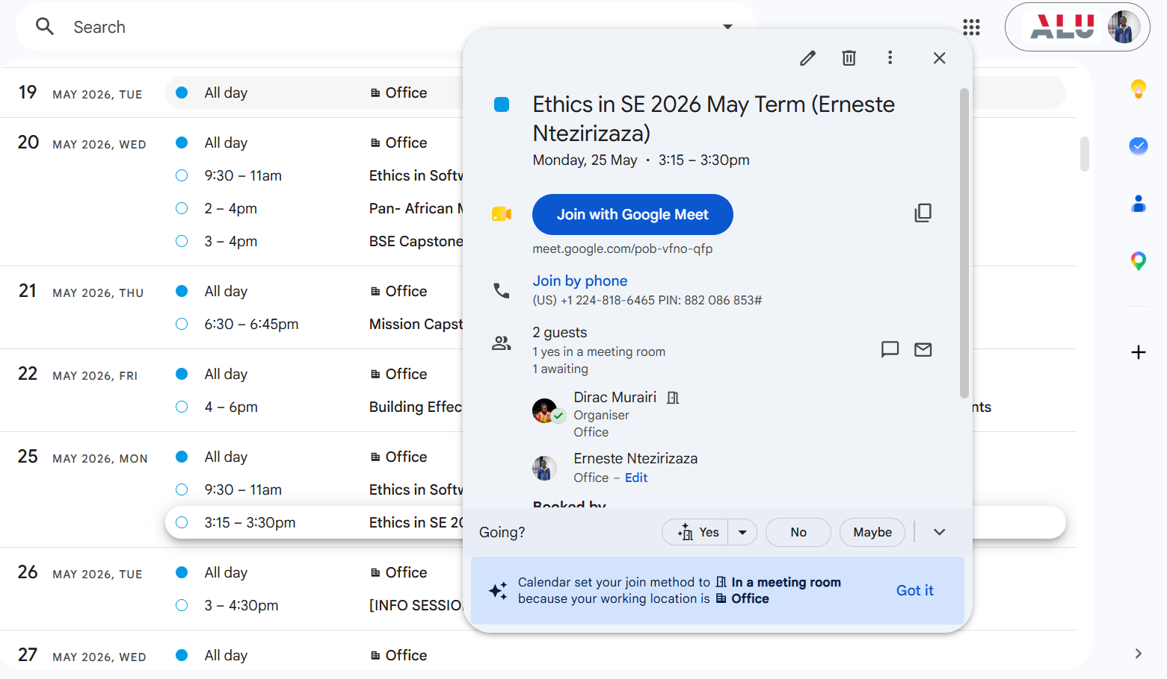
Supervision Meeting Log 4
Date/Time | Wednesday, 27 May 2026 • 3:40–3:55pm (Google Meet)
Meeting Type | Mission Capstone 26-May-Term
Person/Role | Erneste Ntezirizaza (Student) & Dirac Murairi (Supervisor)
Discussion Points | 1. Reviewed supervisor feedback on the research proposal. 2. Finalised the three research questions. 3. Refined the project scope to a unified PPO + CNN planner-and-navigator architecture. 4. Confirmed the eight-week, four-phase implementation timeline.
Action Items | I will revise and resubmit the research proposal incorporating feedback. I will begin building the RwandaReforestEnv Gymnasium environment.
Ethical Issues Raised | We reaffirmed the restriction to ICRAF-validated native species only, to avoid recommending ecologically inappropriate species.
Decisions Made | The proposal was approved to proceed into the dataset-acquisition and environment-build phase.
Calendar confirmation: Mission Capstone 26-May-Term, Wednesday 27 May 2026, 3:40–3:55pm
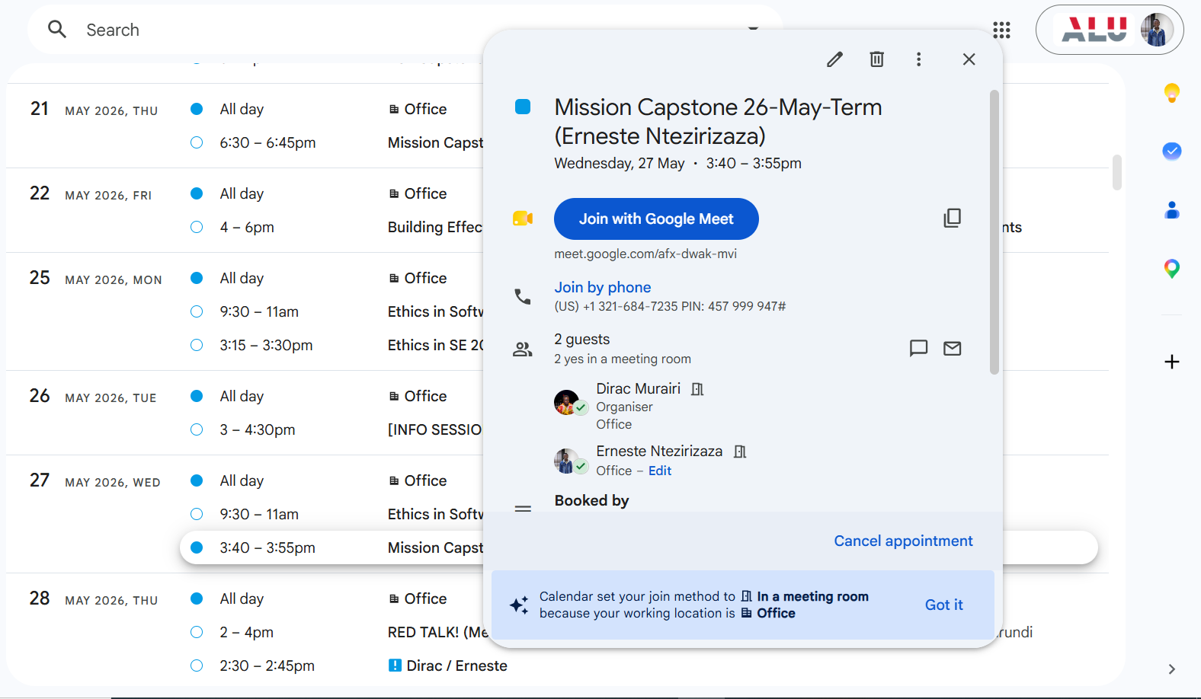
Supervision Meeting Log 5
Date/Time | Thursday, 28 May 2026 • 2:45–3:00pm (Google Meet)
Meeting Type | Intro to ML 2026 May Term
Person/Role | Erneste Ntezirizaza (Student) & Dirac Murairi (Supervisor)
Discussion Points | 1. Covered foundational machine-learning concepts relevant to ARIA's implementation: PPO (Proximal Policy Optimisation), CNN feature encoders, and the OpenAI Gymnasium environment interface. 2. Discussed reward-shaping principles ahead of designing ARIA's six-component reward function. 3. A separate 1-on-1 slot proposed for earlier that afternoon ("Dirac / Erneste", 2:30–2:45pm) was not held after the invitation was declined, so outstanding questions from that request were folded into this session instead.
Action Items | I will review the Gymnasium documentation and begin drafting the reward function design ahead of Log 6.
Ethical Issues Raised | We discussed why reward-shaping choices needed to be documented transparently, since poorly justified reward terms could bias the agent toward unsafe or ecologically inappropriate behaviour.
Decisions Made | We agreed the reward function would be built from six explicit components (soil, rainfall, slope, spacing, protected-area, step penalty) rather than a single opaque score.
Calendar confirmation: Intro to ML 2026 May Term, Thursday 28 May 2026, 2:45–3:00pm
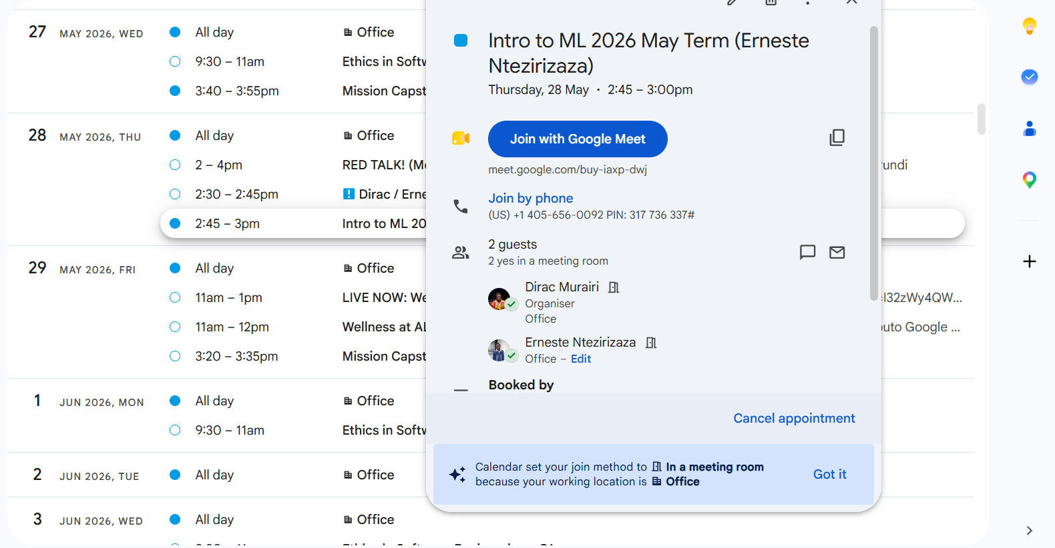
Supervision Meeting Log 6
Date/Time | Friday, 29 May 2026 • 3:20–3:35pm (Google Meet)
Meeting Type | Mission Capstone 26-May-Term
Person/Role | Erneste Ntezirizaza (Student) & Dirac Murairi (Supervisor)
Discussion Points | 1. Confirmed the final list of six geospatial datasets and their licences (CC BY 4.0, Public Domain, Free non-commercial). 2. Planned the acquisition and preprocessing order: DEM, soil, CHIRPS rainfall, land cover, WDPA, ICRAF species. 3. Set up the initial RwandaReforestEnv project structure.
Action Items | I will download and preprocess all six datasets. I will scaffold the Gymnasium environment class ahead of Log 7.
Ethical Issues Raised | We reconfirmed that no private, personal, or community-rights data would be used anywhere in the pipeline.
Decisions Made | Dataset acquisition was approved to begin immediately, in parallel with literature review.
Calendar confirmation: Mission Capstone 26-May-Term, Friday 29 May 2026, 3:20–3:35pm
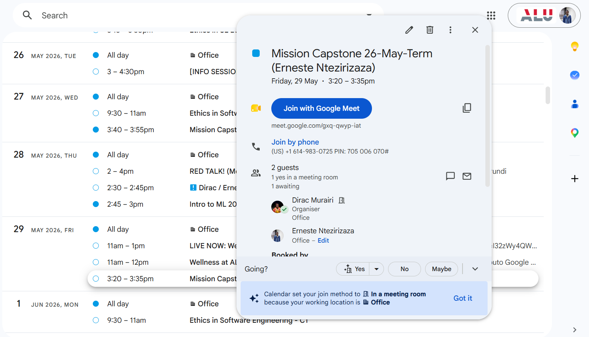
Supervision Meeting Log 7
Date/Time | Wednesday, 17 June 2026 • 3:40–3:55pm (Google Meet)
Meeting Type | Mission Capstone 26-May-Term
Person/Role | Erneste Ntezirizaza (Student) & Dirac Murairi (Supervisor)
Discussion Points | 1. Defined the structure of the six-dataset pipeline in detail. 2. Designed the state and action space for the Gymnasium environment. 3. Discussed the zone-based dataset partitioning strategy: 36 training zones and 6 held-out zones, stratified across all six agro-ecological regions. 4. Reviewed how WDPA protected-area boundaries would be enforced inside the environment.
Action Items | I will complete and validate RwandaReforestEnv using gym.utils.env_checker. I will finalise the 36/6 zone split with no spatial overlap.
Ethical Issues Raised | We agreed WDPA boundaries must be enforced as a hard constraint on the action space, not an optional post-hoc filter.
Decisions Made | The dataset structure and zone-split methodology were approved; I proceeded to reward-function implementation.
Calendar confirmation: Mission Capstone 26-May-Term, Wednesday 17 June 2026, 3:40–3:55pm
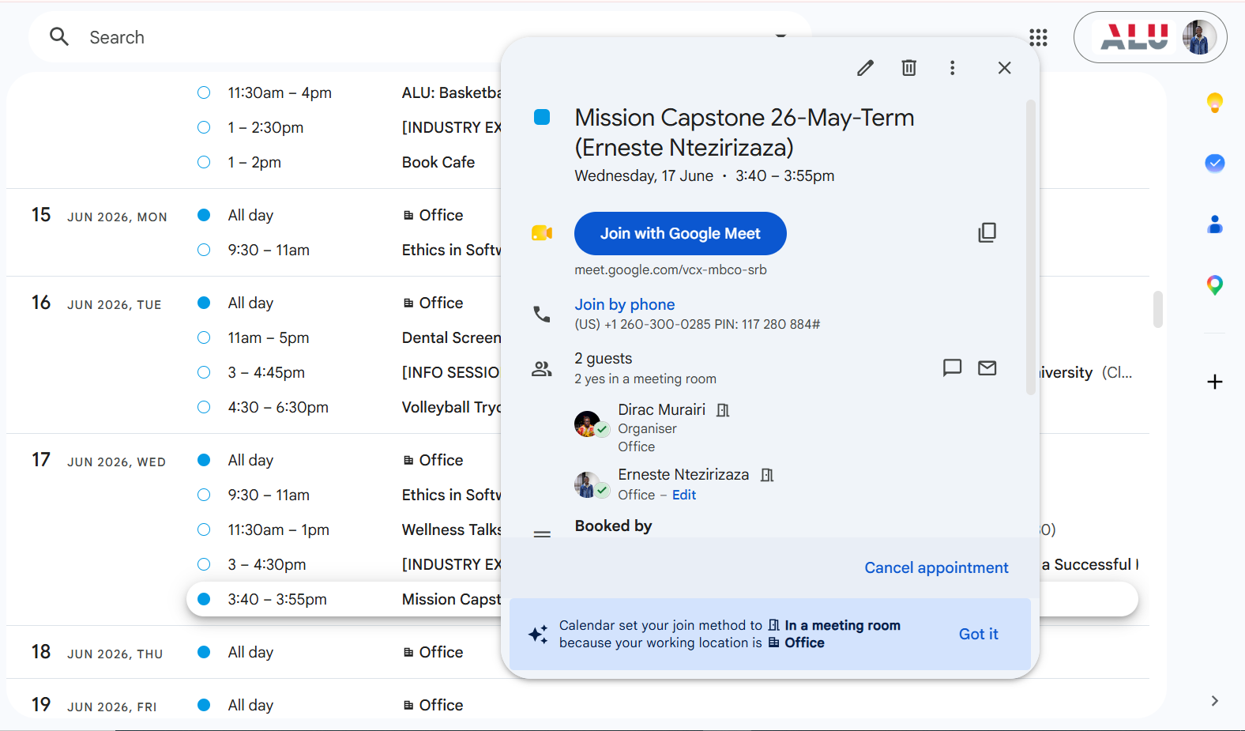
Supervision Meeting Log 8
Date/Time | Thursday, 18 June 2026
Meeting Type | REC Ethics Clearance Notification
Person/Role | Erneste Ntezirizaza (Student), ALU Senate Research Ethics Committee (Venuste Niyonzima, Chairperson), and Dirac Murairi (Supervisor)
Discussion Points | 1. Notification of REC approval received: Approval Code M26-BSE-043. 2. Reviewed the required ethical guidelines: informed consent, consent for recording, protection of vulnerable participants, confidentiality, and avoidance of coercion, relevant should any future consultation with the Rwanda Forestry Authority or affected communities take place. 3. Noted the six-month validity window and the requirement to notify the REC of any significant methodology change.
Action Items | I will file the REC approval letter with the Capstone documentation. I noted the 48-hour reporting obligation for any procedural change involving human subjects.
Ethical Issues Raised | We discussed the obligation to report any change in procedure or scope to the REC within 48 hours of it occurring.
Decisions Made | REC approval was filed and confirmed active for the remainder of the Capstone period.
Evidence for this entry is the REC approval letter itself (Part 1), rather than a calendar screenshot.
Supervision Meeting Log 9
Date/Time | Friday, 19 June 2026 • 11:20–11:35am (Google Meet)
Meeting Type | Mission Capstone 26-May-Term
Person/Role | Erneste Ntezirizaza (Student) & Dirac Murairi (Supervisor)
Discussion Points | 1. Confirmed the WDPA hard-constraint implementation was working correctly in early environment tests. 2. Reviewed the finalised 36/6 zone split for training and held-out evaluation. 3. Began discussing the unified PPO + CNN planner-and-navigator architecture in more technical detail.
Action Items | I will begin implementing the PPO training loop and the CNN feature encoder for the state representation.
Ethical Issues Raised | We reconfirmed all six datasets remained openly licensed with no personal or community-rights data as implementation progressed.
Decisions Made | The environment and constraint implementation were approved; training could begin.
Calendar confirmation: Mission Capstone 26-May-Term, Friday 19 June 2026, 11:20–11:35am
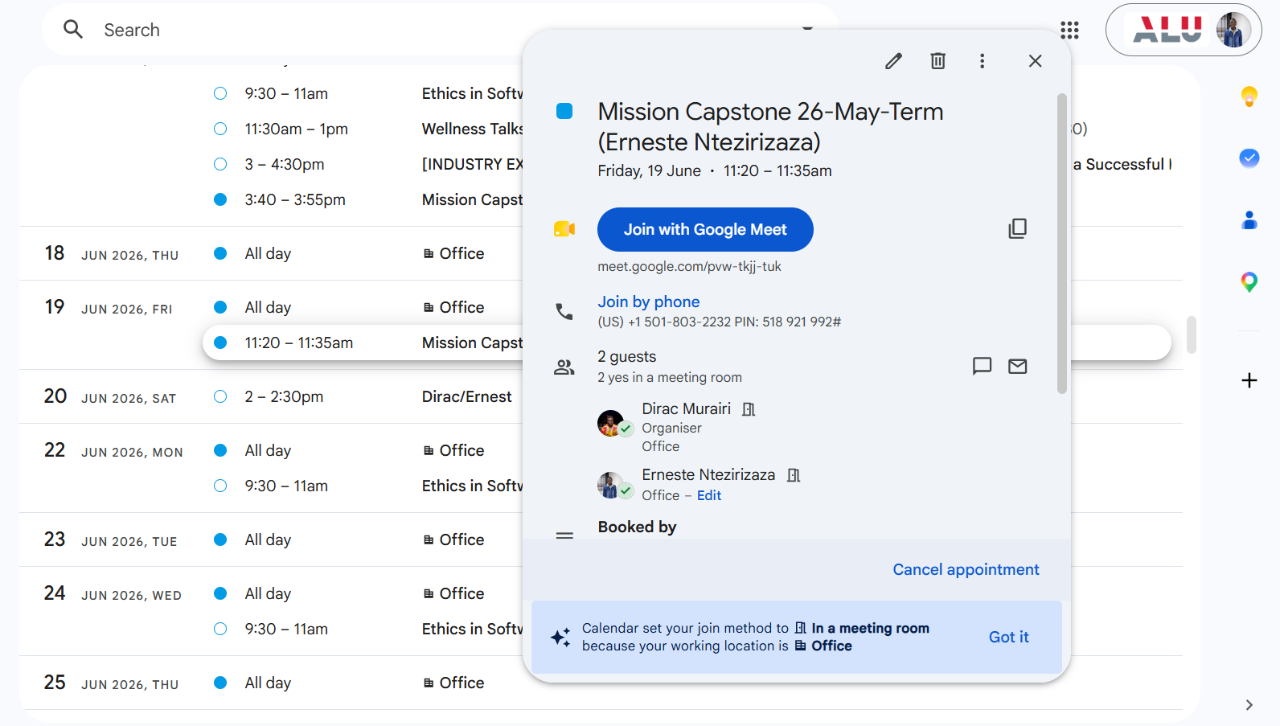
Supervision Meeting Log 10
Date/Time | Saturday, 20 June 2026 • 2:00–2:30pm (Google Meet)
Meeting Type | Ad hoc 1-on-1 ("Dirac/Ernest")
Person/Role | Erneste Ntezirizaza (Student) & Dirac Murairi (Supervisor)
Discussion Points | 1. Reviewed early PPO training runs from the spacing-penalty ablation sweep. 2. Identified signs of overfitting, where training performance was not translating to the held-out evaluation zones. 3. Discussed possible causes, including reward shaping and the training/evaluation zone split.
Action Items | I will investigate reward-shaping adjustments and re-verify the strict zone-level train/held-out split. I will re-run affected ablation configurations before the next check-in.
Ethical Issues Raised | We discussed the importance of honestly reporting model limitations rather than presenting only favourable training runs.
Decisions Made | We agreed to document the overfitting issue and its resolution transparently in the final report's limitations section.
Calendar confirmation: ad hoc 1-on-1 ("Dirac/Ernest"), Saturday 20 June 2026, 2:00–2:30pm
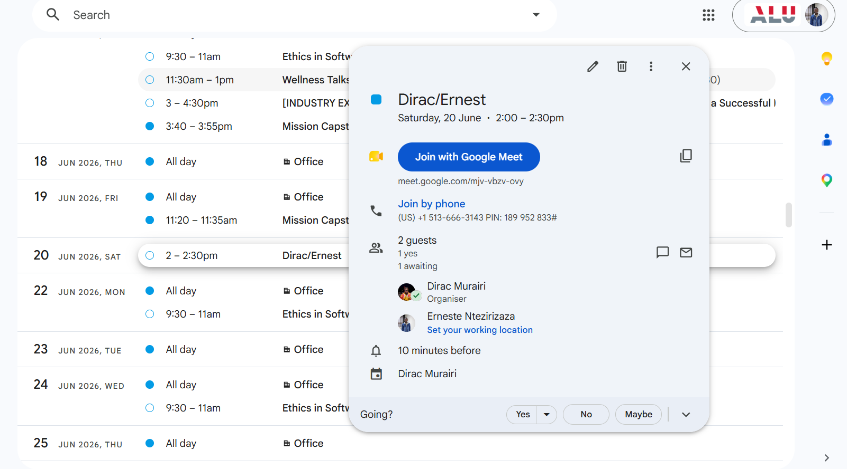
Supervision Meeting Log 11
Date/Time | Tuesday, 14 July 2026 • 4:00–5:00pm (Google Meet)
Meeting Type | Defense Final Meeting 1
Person/Role | Erneste Ntezirizaza (Student) & Dirac Murairi (Supervisor)
Discussion Points | 1. Confirmed the overfitting/generalisation issue identified in Log 10 was resolved. 2. Reviewed held-out zone performance: 41.9%–60.5% of each zone's achievable seeding ceiling, with zero protected-area violations across all six zones. 3. Reviewed the production dashboard, Postgres telemetry schema, and the Unity WebGL deployment at aria-capstone.vercel.app. 4. Began reviewing the complete six-chapter capstone report.
Action Items | I will finalise the results and limitations sections and prepare for the second defense session.
Ethical Issues Raised | We reaffirmed the need to flag low-confidence predictions for Eastern Savanna South given its comparatively weaker data coverage.
Decisions Made | The generalisation results were accepted as valid for the final report.
Calendar confirmation: Defense Final Meeting 1, Tuesday 14 July 2026, 4:00–5:00pm
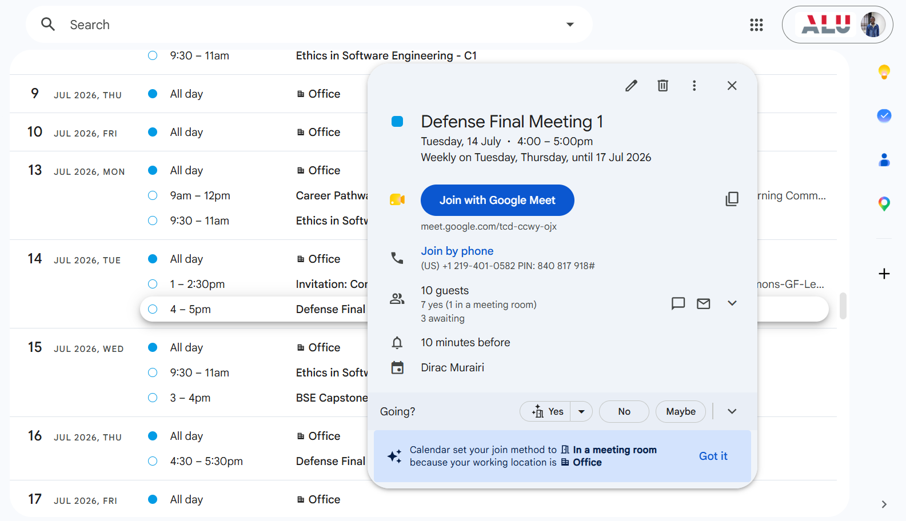
Supervision Meeting Log 12
Date/Time | Thursday, 16 July 2026 • 4:30–5:30pm (Google Meet)
Meeting Type | Defense Final Meeting 1
Person/Role | Erneste Ntezirizaza (Student) & Dirac Murairi (Supervisor)
Discussion Points | 1. Final review of the complete six-chapter capstone report. 2. Discussed results mapped against the three research questions. 3. Reviewed limitations: the incomplete reward-component ablations, the absence of a baseline comparison, and the zone-selector component's unused weights. 4. Discussed the five prioritised recommendations for future work. 5. Resolved a misunderstanding about the final demo submission deadline caused by a group-chat announcement.
Action Items | I will complete final formatting and APA referencing. I will prepare the Ethics Summative deliverables: journal, frameworks, EULA/Privacy page, video.
Ethical Issues Raised | We confirmed all dataset licensing and the non-use of personal or community data were properly documented in the final report, and reaffirmed the decision-support framing throughout.
Decisions Made | The final capstone report was approved as ready for submission.
Calendar confirmation: Defense Final Meeting 1, Thursday 16 July 2026, 4:30–5:30pm
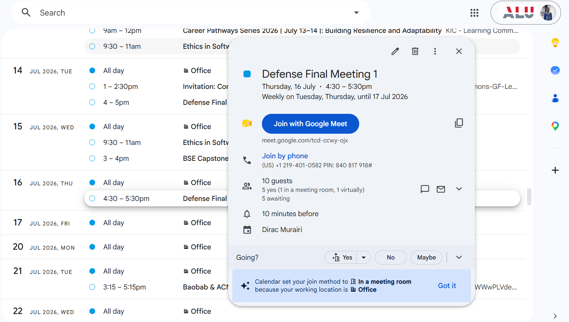

Iteration Evidence
The following examples demonstrate how feedback informed concrete changes during development:
Iteration 1: Overfitting Fix in the Spacing-Penalty Ablation Sweep
- What changed: investigated and corrected an overfitting issue in the PPO training runs, adjusting the training approach for the affected spacing-penalty configurations.
- Why it changed: early training results showed signs that the policy was not generalising, which risked making the held-out zone evaluation unreliable.
- Feedback that informed change: supervisor discussion during Log 10 (20 June 2026), with the resolution confirmed in Log 11 (14 July 2026).
Iteration 2: Strict Zone-Level Train/Held-Out Split
- What changed: enforced a strict zone-level split, 36 training zones and 6 held-out zones with no spatial overlap, rather than a naive random split of terrain cells.
- Why it changed: a naive split risked leaking information between training and evaluation zones, which would have made the generalisation results look artificially strong.
- Feedback that informed change: raised during the dataset-structure discussion in Log 7 (17 June 2026) and confirmed in the final report's methodology section.
Iteration 3: Low-Confidence Flagging for Under-Represented Zones
- What changed: output maps were redesigned to flag areas of low prediction confidence rather than presenting every recommendation with equal certainty, and Eastern Savanna South was deliberately retained as a held-out evaluation zone despite its weaker data coverage.
- Why it changed: without this change, the system risked masking a deployment bias against already under-served regions rather than surfacing it for human review.
- Feedback that informed change: raised during the Ethics in SE session in Log 3 (25 May 2026) and reaffirmed during the REC review and limitations discussion in Logs 8 and 12.

Project Roadmap
Phase 1: Foundation (Weeks 1–3)
# | Weeks | Milestone / Deliverable | Status
1.1 | W1 | Literature review across 4 academic platforms (22 papers) | Completed
1.2 | W2 | Acquire and preprocess 6 Rwanda geospatial datasets (DEM, soil, rainfall, land cover, WDPA, species) | Completed
1.3 | W3 | Build and validate RwandaReforestEnv (gym.utils.env_checker) | Completed

Phase 2: Unified Planner + Navigator — RL Core (Weeks 3–4)
# | Weeks | Milestone / Deliverable | Status
2.1 | W3 | Design 6-component reward function (soil, rain, slope, spacing, protected-area, step penalty) | Completed
2.2 | W3–W4 | Implement unified PPO+CNN policy: single forward pass for mission-level and step-level decisions | Completed

Phase 3: Simulation Systems + Training (Weeks 4–6)
# | Weeks | Milestone / Deliverable | Status
3.1 | W5 | Energy system (solar/battery), weather system + rain cover mechanism | Completed
3.2 | W5 | Obstacle detection/avoidance + animal disturbance engine | Completed
3.3 | W6 | Seed monitoring & automatic reseeding pipeline | Completed
3.4 | W6 | Spacing-penalty ablation: 5 configs × 200k timesteps | Completed

Phase 4: Web, Telemetry Dashboard & Evaluation (Weeks 7–8)
# | Weeks | Milestone / Deliverable | Status
4.1 | W7 | Postgres schema + telemetry write pipeline + real-time dashboard | Completed
4.2 | W7 | Unity WebGL build + ONNX inference deployment (aria-capstone.vercel.app) | Completed
4.3 | W8 | Generalisation evaluation across 6 held-out zones (efficiency vs. achievable ceiling) | Completed
4.4 | W8 | Final report write-up and submission | Completed

Privacy Policy & Terms of Use
Last updated: July 2026
1. Introduction
ARIA ("the System") is a reinforcement-learning decision-support tool for terrain-adaptive drone reforestation in Rwanda. It comprises a trained PPO policy, a Unity WebGL simulation, and a telemetry dashboard. ARIA does not control physical drones and does not make final planting decisions. Every output is a simulated recommendation requiring field verification by the Rwanda Forestry Authority.
2. Data We Collect
ARIA collects only simulation and telemetry data: completed-episode records (zone, seeds placed, rewards, spacing metrics, protected-area checks) and failure/incident data generated during simulated missions. It does not collect names, contact details, location data about individual users, or any other personally identifiable information. All six geospatial datasets used to train the model (elevation, soil, rainfall, land cover, protected areas, species suitability) are openly licensed and contain no private or community-rights data.
3. How We Use Data
Episode telemetry is used to populate the real-time dashboard, to support evaluation of the trained policy's performance, and to inform future model improvement. No data collected by the System is used for any purpose beyond research, evaluation, and demonstration of the decision-support tool.
4. AI-Assisted Decision-Making
ARIA's unified planner-and-navigator policy is a PPO-trained reinforcement-learning model that recommends seed placement and reseeding actions within the simulation. It does not make final real-world planting decisions. All protected-area boundaries are enforced as a hard constraint, and low-confidence predictions are flagged rather than presented with equal certainty to higher-confidence ones. Every recommendation requires field verification by the Rwanda Forestry Authority before any real-world action is taken.
5. Data Sharing
Episode and telemetry data are stored in the project's Postgres database and are accessible to the project team and, where relevant, the Rwanda Forestry Authority for evaluation purposes. Data is not sold or shared with third parties for commercial purposes.
6. Data Storage & Security
- Telemetry data is written to Postgres via a Next.js API route at the end of each simulated episode.
- The dashboard reads the same data back out from Postgres when a user opens it.
- The System does not store any personal or community-rights data.
7. Your Rights
Because ARIA does not collect personal data from individual users, no personal-data access, correction, or deletion requests apply to the current system. Any future version that begins collecting personal data, for example RFA operator accounts, would need to extend this section accordingly.
8. Terms of Use (EULA)
By using the ARIA dashboard or simulation, users agree to:
- Treat all output as decision-support only, not as a final planting authorisation
- Seek field verification from the Rwanda Forestry Authority before acting on any recommendation
- Not misrepresent simulation results as validated field outcomes
9. Changes to This Policy
This policy will be updated as ARIA moves from a research prototype toward a field-facing tool, particularly if future versions begin collecting operator or community data.
10. Contact
For questions about this policy or the System, please contact the project supervisor or submit an issue via the project repository.

Academic Integrity and AI Use Disclosure
This submission reflects my own intellectual work on the ARIA Capstone project. All sources are cited accurately and all borrowed ideas are acknowledged in the References section.
AI tool used | Claude (Anthropic)
Purpose | Assisted in structuring and drafting this Ethics Summative submission — organising my Capstone Final Report, Capstone Communication & Availability Report, and REC approval letter into the assessment's required Declaration, Ethical Risks, Frameworks, Journal, Roadmap, and Privacy Policy sections.
Extent of revision | All ethical risks, framework analysis, journal entries, and roadmap content are drawn directly from my own completed Capstone report and supervision records. I reviewed, verified, and take full responsibility for the accuracy and originality of the final text.

References
AFR100. (2025). Rwanda Eastern Province ROAM and forest landscape restoration strategy 2024–2030. Winrock International / AFR100. https://afr100.org
ALU Senate Research Ethics Committee. (2026, June 18). Ethics approval for research project [Approval Code: M26-BSE-043] [Letter]. African Leadership University.
Association for Computing Machinery. (2018). ACM code of ethics and professional conduct. https://www.acm.org/code-of-ethics
Government of Rwanda. (2024). National Strategy for Transformation 2 (NST2), 2024–2029. Ministry of Finance and Economic Planning.
ICRAF. (2022). Suitable tree species for Rwanda [Data set]. World Agroforestry Centre (ICRAF). https://doi.org/10.34725/DVN/RLQV3H
UNEP-WCMC & IUCN. (2026). Protected Planet: The World Database on Protected Areas (WDPA) [March 2026 release]. https://www.protectedplanet.net/country/RWA

